WANDORA
Final UI Design
PA4 - Revised UI Prototype
Decision rationale
The Product Assistant direction presents Wandora as a focused shared-planning workspace. It makes trip progress, group input, AI guidance, itinerary changes, and preparation status visible in one coherent flow.
This final document replaces the earlier landing-page alternative. It contains one selected visual direction and the high-fidelity screens used to validate the PA4 use cases.

FINAL DESIGN SYSTEM
Visual language
A warm paper workspace with forest-green actions, soft sage AI states, restrained rounded containers, and readable editorial hierarchy.
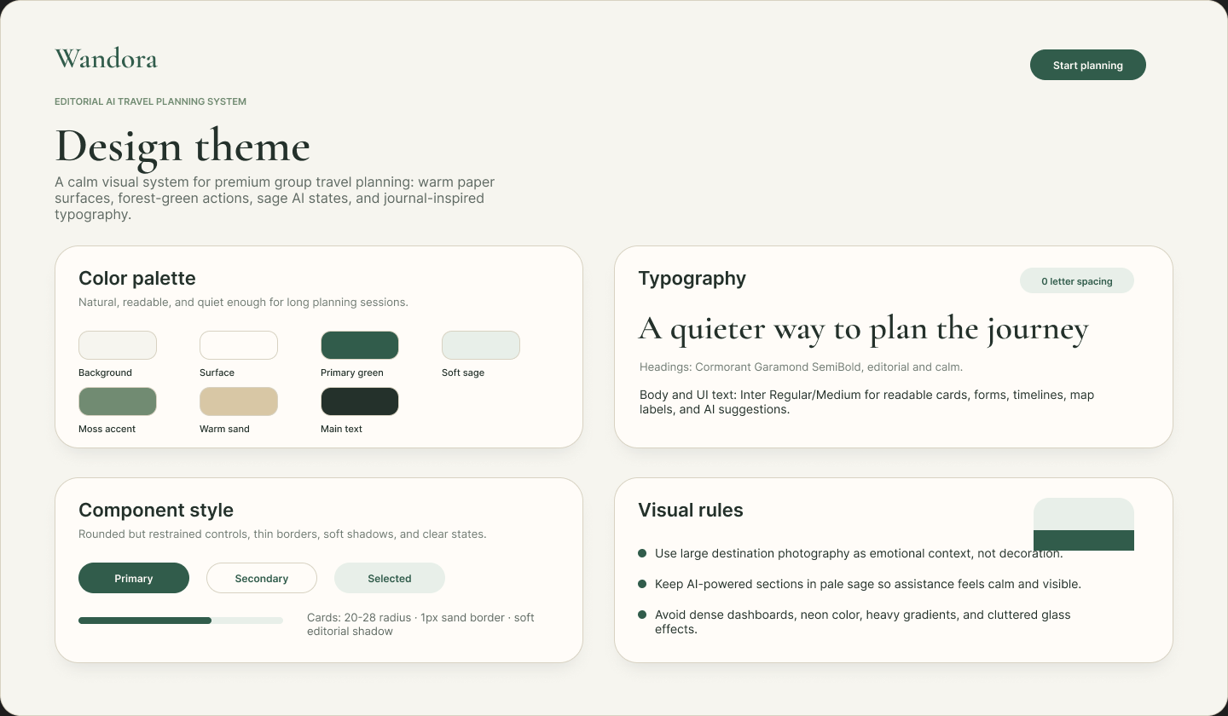
Interaction conventions
Primary actions use forest green. AI assistance uses pale sage. Status, progress, and decisions remain visible without overpowering planning content. Forms use clear labels and compact grouped choices for repeated travel inputs.

FINAL UI SCREEN 01
Landing page
Entry point for the selected Product Assistant direction. It explains the shared planning value and leads users into workspace creation.
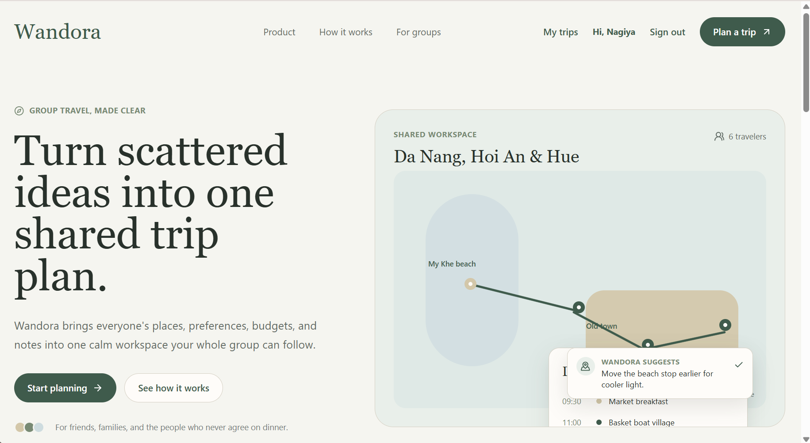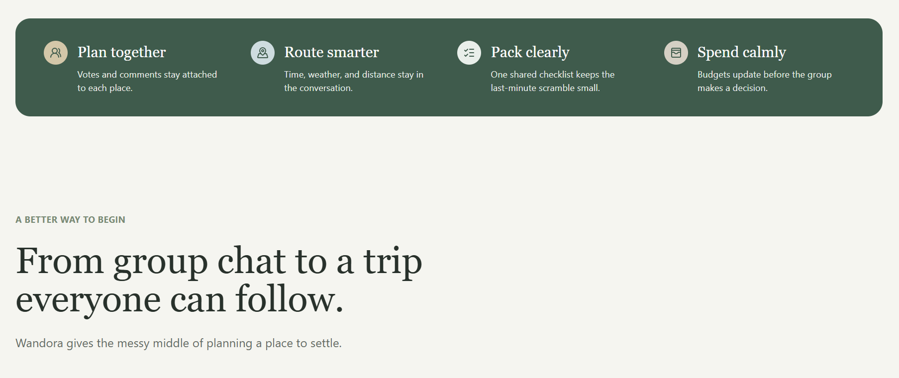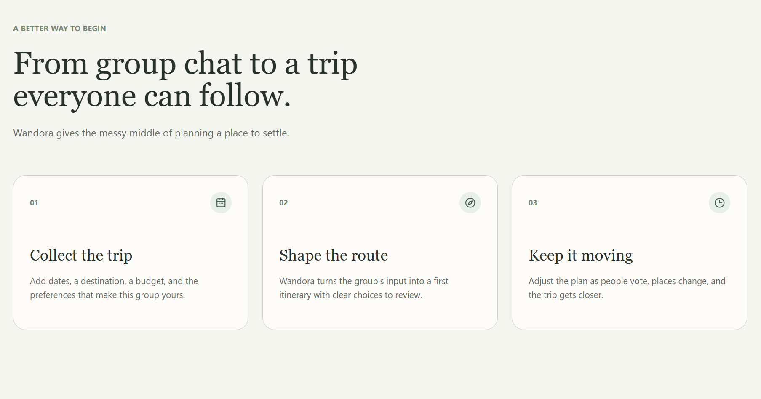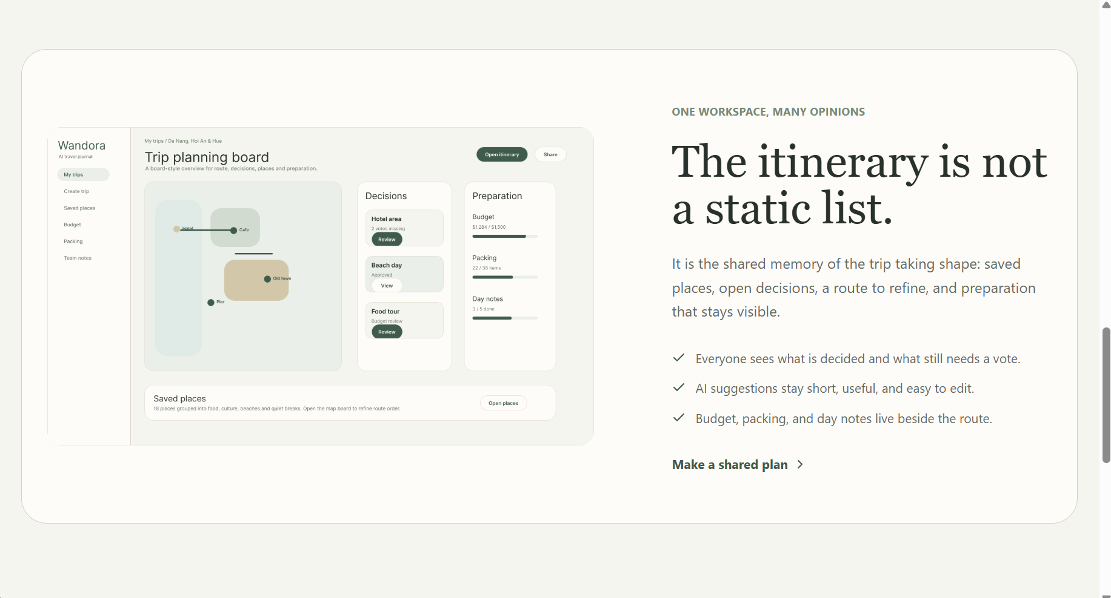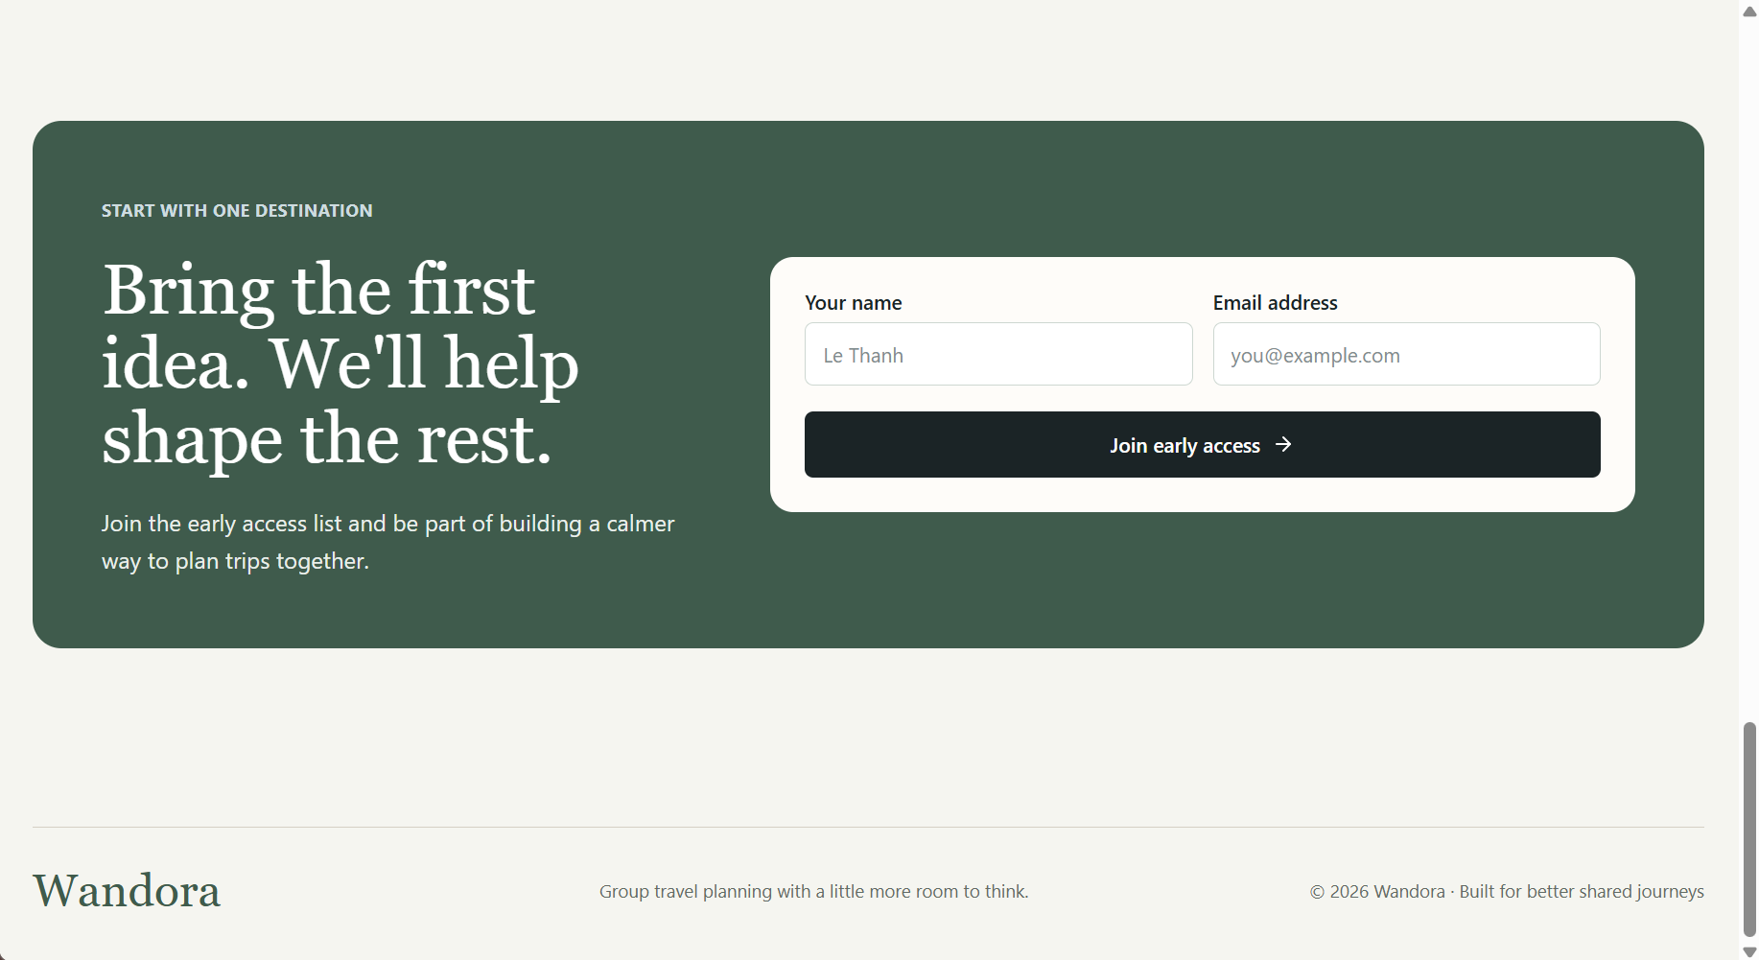

Key signals: collaborative planning, AI route assistance, packing visibility, budget awareness, and a direct create-workspace action.

FINAL UI SCREEN 02
My trips dashboard
A searchable workspace index that lets travellers resume drafts, open planning trips, and scan progress at a glance.
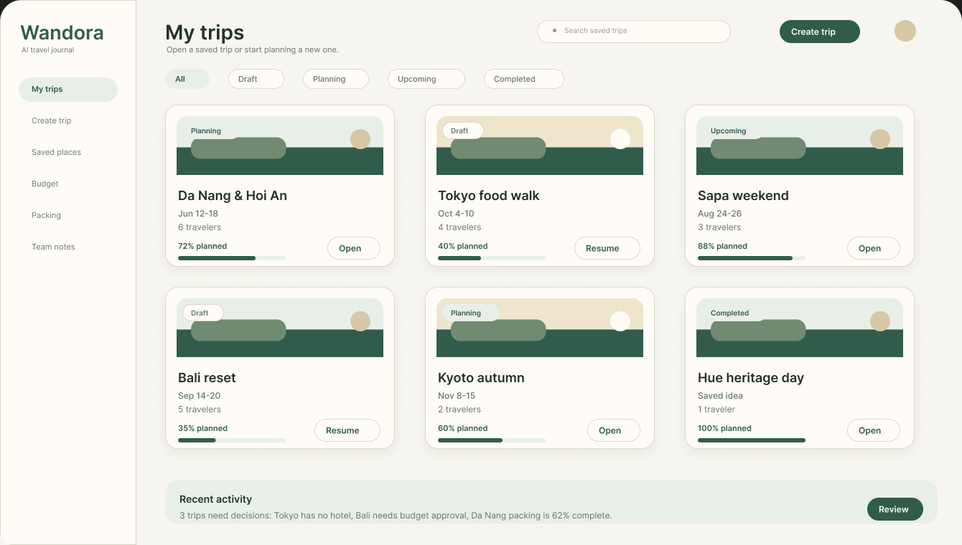
Use-case coverage: authenticated access to private trip workspaces, trip status, and entry into an existing planning flow.

FINAL UI SCREEN 03
Create trip - invite members
Step 1 captures collaborators and roles before the trip details are collected.
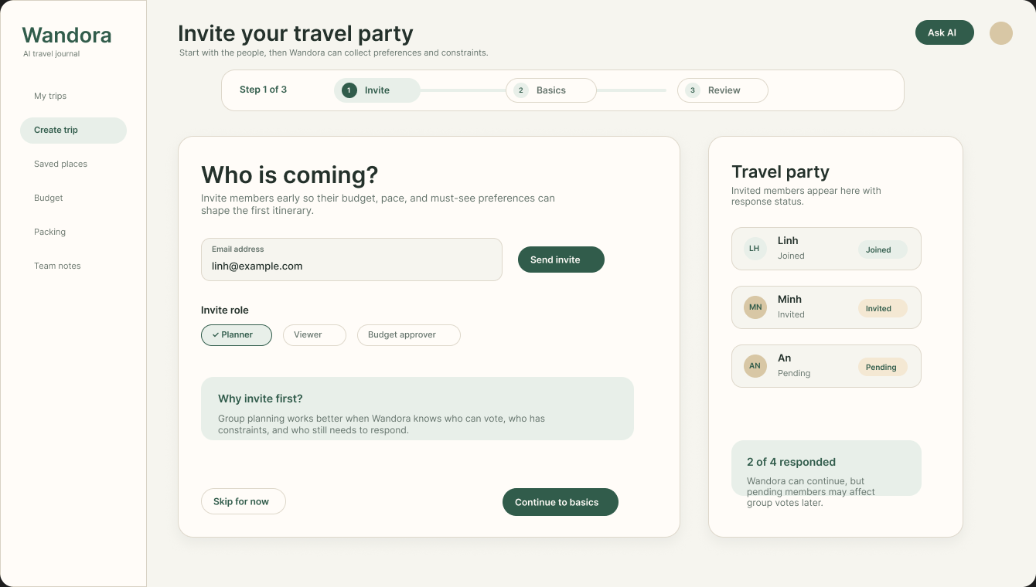
Use-case coverage: group collaboration and role/permission management. The user can invite members, choose a role, and see invitation status.

FINAL UI SCREEN 04
Create trip - trip basics
Step 2 collects destination, dates, traveller count, budget, and high-level travel style.
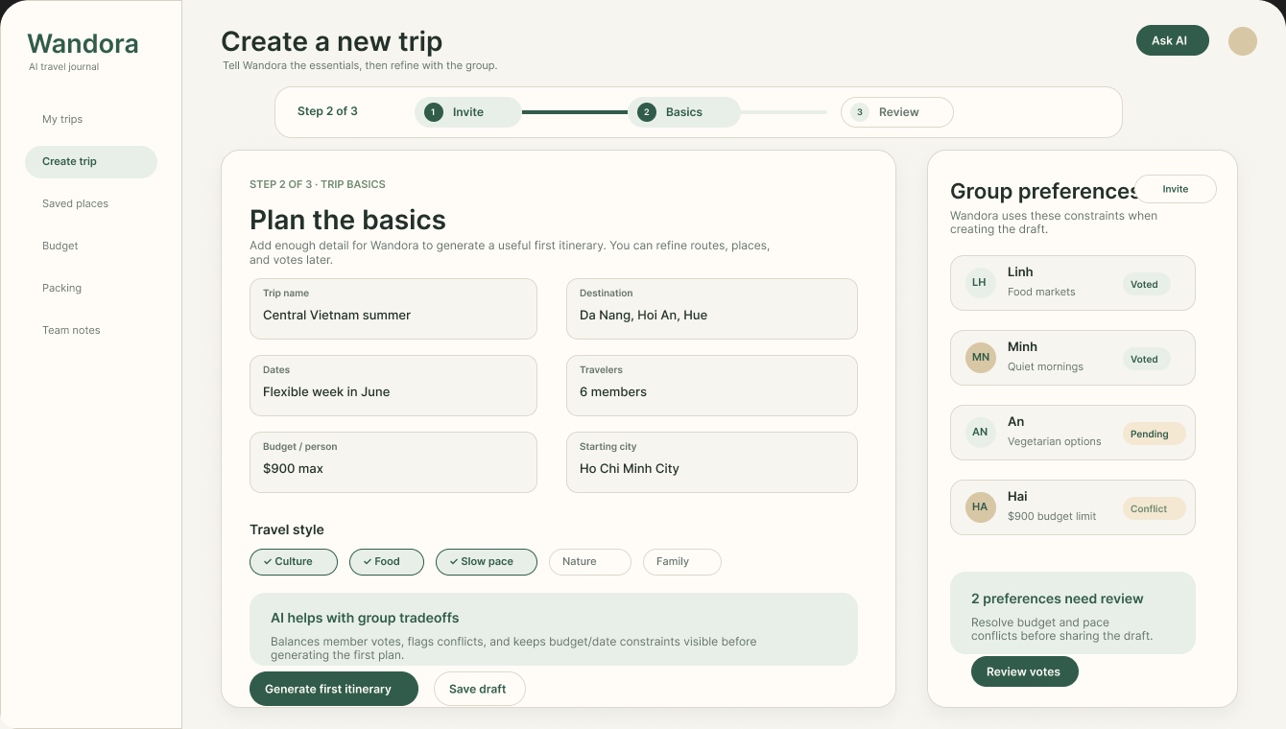
Use-case coverage: trip creation and preference input. The side panel keeps each member's preferences visible before itinerary generation.

FINAL UI SCREEN 05
Create trip - preferences review
Step 3 resolves group preferences and conflicting constraints before AI generation.
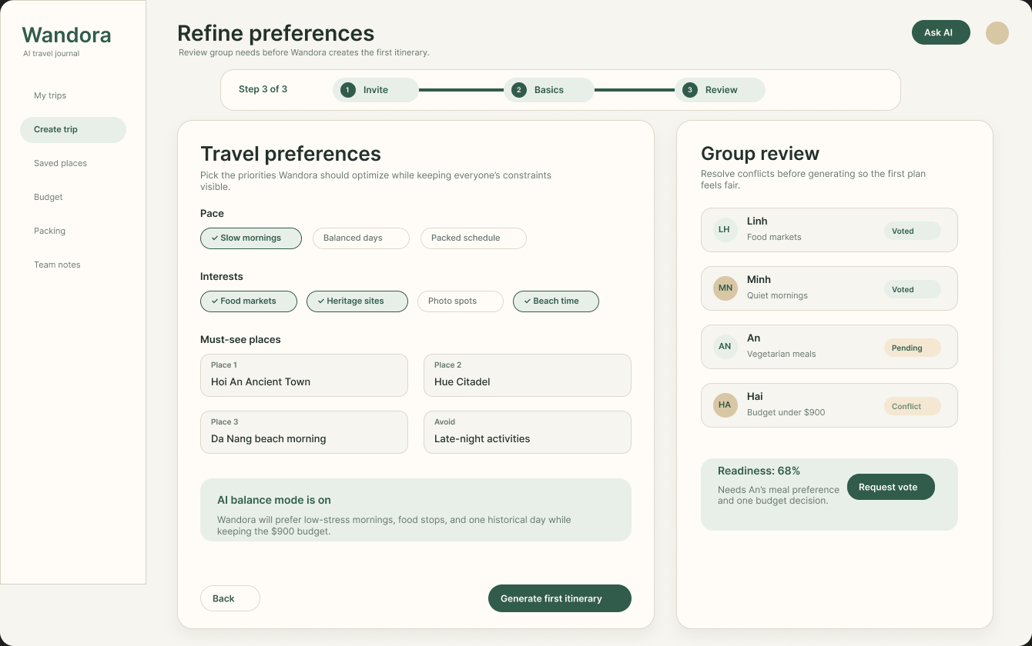
Use-case coverage: AI itinerary generation, group interaction, and preference conflict review. The generate action is available only after the review step.

FINAL UI SCREEN 06
Saved trip summary
A selected-trip overview shows progress, members, packing, budget, saved places, pending decisions, and an itinerary preview.
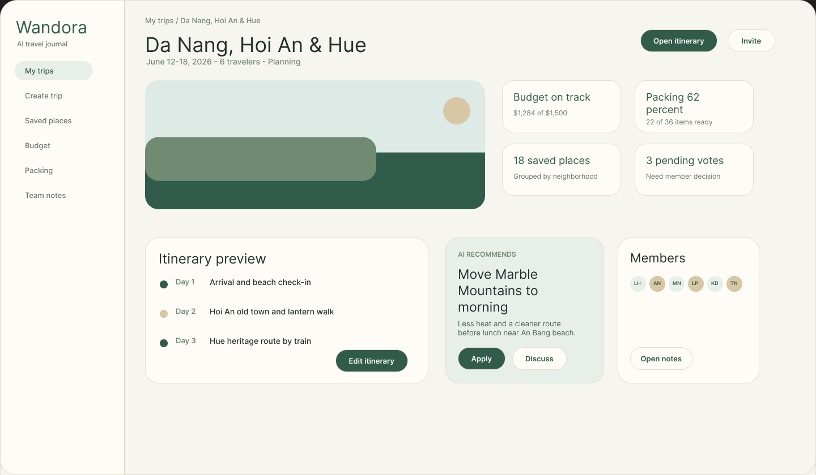
Use-case coverage: post-scheduling feature access. It creates one clear hub before users open the detailed itinerary or preparation tools.

FINAL UI SCREEN 07
Planning board
An alternative operational view for saved-trip decisions, routes, saved places, and preparation progress.
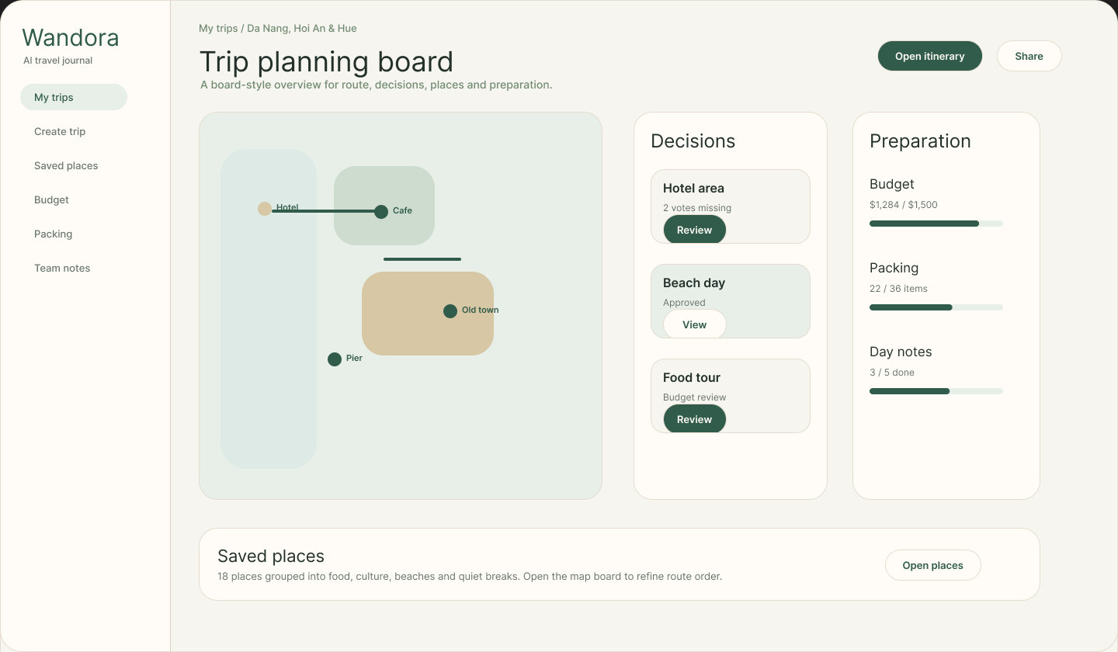
Use-case coverage: group planning, budget and packing visibility, and saved-place context. This is a complementary view of the same saved workspace.

FINAL UI SCREEN 08
Itinerary workspace
Day-by-day itinerary view for reviewing AI output, adding activities, editing activities, and discussing suggested changes.
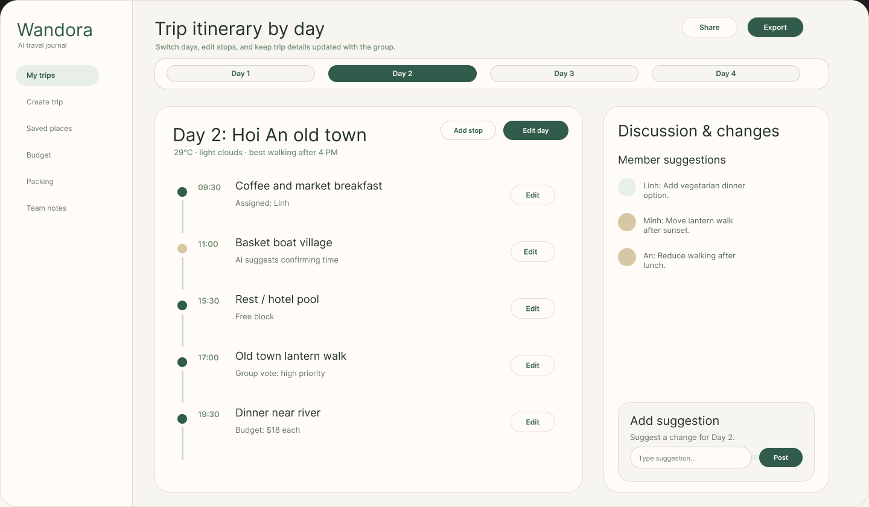
Use-case coverage: AI itinerary adjustment, manual activity management, group suggestions, and share/export. Activities support add, edit, remove, and undo feedback in the working application.

USE-CASE ALIGNMENT
UI coverage for PA4
The selected Product Assistant design follows the lifecycle documented in the Use-Case Specification: enter trip details, generate an AI preview, review and adjust activities, save the itinerary, then continue planning from the workspace.
UC | Use case | Design evidence
2.1 | Trip Creation and Preference Input | Create trip steps: Invite, Basics, and Review.
2.2 / 2.13 | AI Itinerary Generator / Review and Save AI Itinerary | Preference review, AI guidance, generate action, itinerary preview, and saved-trip entry.
2.3 | AI Itinerary Adjustment | Day-by-day itinerary workspace with editable activities and AI-supported changes.
2.4 / 2.9 | Manual Places, External Links, and Place Notes | Saved places navigation and the planning-board context for places and decisions.
2.5 / 2.15 | Group Collaboration, Voting, and Comments | Invitations, group review, member suggestions, and discussion panel.
2.6 | Role and Permission Management | Role selector and member status at the invite step.
2.7 / 2.8 | AI Packing Suggestions and Shared Luggage Planning | Packing navigation and preparation progress in saved-trip overview and planning board.
2.10 / 2.11 | Ratings, Reviews, and Share/Export | Workspace navigation plus visible Share and Export actions in the itinerary view.
2.12 | User Login and Authentication | Private workspace entry is represented by the signed-in dashboard flow.
2.14 / 2.16 / 2.17 | Post-Scheduling Access, Duplicate Check, and Trip History | Trip cards, saved-workspace entry, planning status, and activity/progress history surfaces.
Submission note
This file is the final selected UI design for PA4. Product Assistant is the sole selected landing direction; earlier alternatives are intentionally excluded from the final screen set.

